**AZURE ML**

THIS EXAMPLE DEMONSTRATES HOW TO PERFORM MULTICLASS DECISION FOREST ALGORITHM ON THE FOREST FIRES DATA ALSO CHECK ITS PERFORMANCE AND THEN EVALUATING THE DATA.

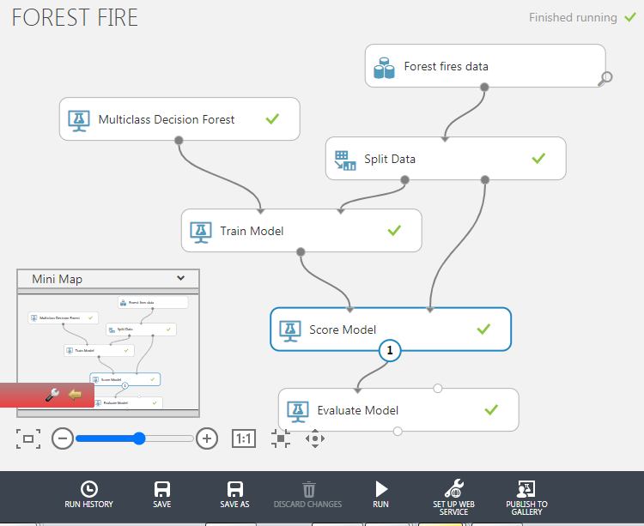

MODEL

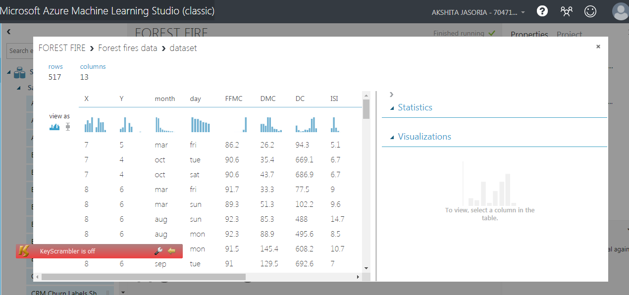

TOTAL DATA SET

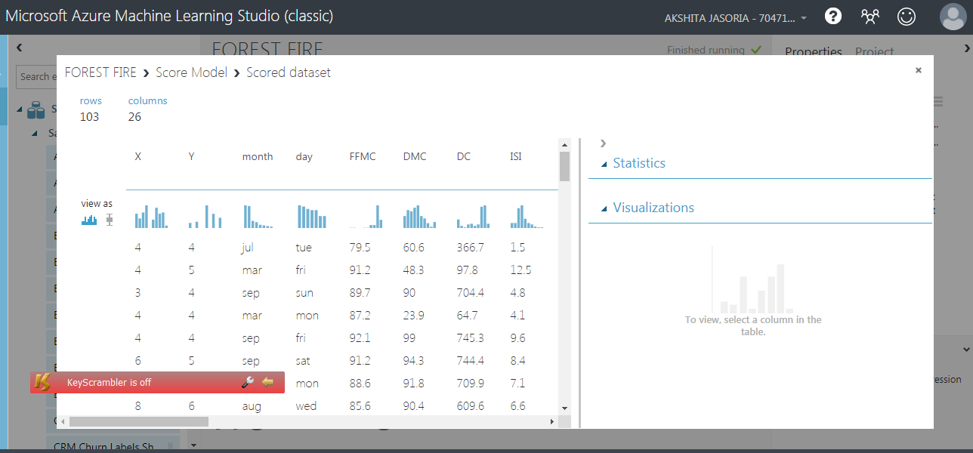

TESTING DATA(20%)

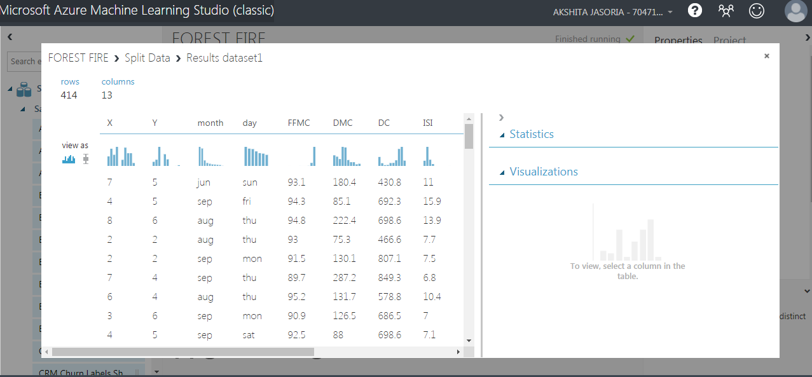

TRAINING DATA(80%)

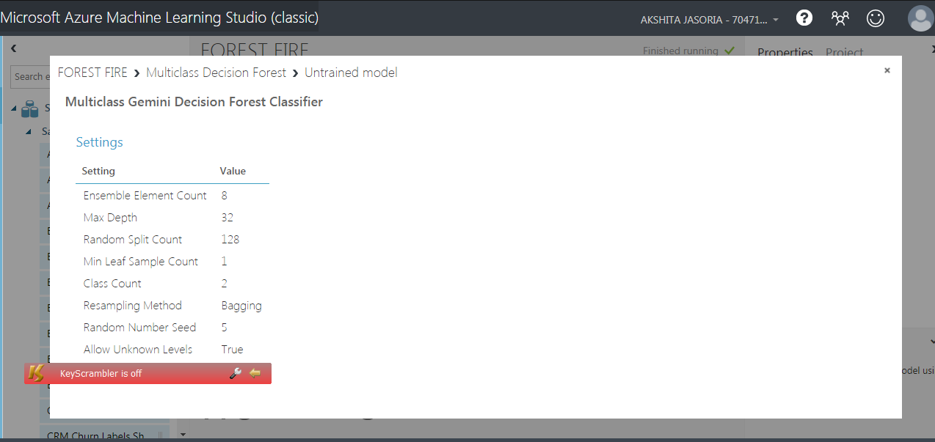

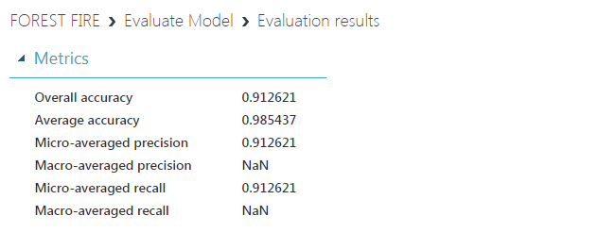

THE EVALUATION MODEL IS SYSTEMATIC APPROACH THAT WILL GUIDE IN MEASURING THE EFFICIENCY AND EFFECTIVENESS OF THE TRAINED DATA.

